**LIVE PROJECT REPORT**

This is the report of a marketing dataset of XYZ. It includes dataset which includes Regions, Stores, Products, Customers and Transactions. I have made a dashboard in power bi based on the datasets. The first dataset is the customers which includes customer details of all the customers related to the company like customer account number, birth date, address, city, country, etc. which shows the dataset of customers.

The next dataset is the Products which shows the details of all the products like low fat products, brand ,cost, id, name, weight, etc. which gives the details of all the products.

The next dataset is the regions which gives the details in which regions the sales is highest according to district and regions.

The next dataset is the stores which shows the details of the stores of the company. It includes datasets like store city, store country, store type, store_street_address, etc.

The last dataset is the transactions which shows the details of the transactions happened in the company. It includes datasets like stock date, transaction date, store id, product id, customer id, etc.

**OBSERVATIONS**

I have some Dax measures that will help analyze the company better so that can make better decisions in the future for the betterment of the company. The dax measures that I made are expenses, profit, profit margin, quantity sold, revenue, total orders, total returns.

The top 10 observations that can be inferred from the following are:

1. The highest returns is from qtr 4 from the supermarket stores of 136,978.82.
2. The highest revenue among the product sku is 142.82 from 57473323941.
3. The total revenue is of 1.20 million
4. The total expenses is 483.62 K
5. The highest profit margin is in the month of may.
6. The highest number of order comes from hildago that is 1559
7. Profit margin is of 0.71
8. The highest revenue is 1.74 K
9. The highest revenue comes from the females
10. The highest revenue comes from the city Hidalgo
11. The highest revenue comes from the product: Even better large curd cottage cheese
12. The most profitable state province is WA in the month of December.

**Questions:**

The main questions that I addressed are:

1. **Evaluate the revenue and expenses**
2. **Identify the returns and develop a chart for the same.**
3. **Evaluate the products that generate the highest revenue.**
4. **Evaluate the highest profit margin**
5. **Create a SKU wise detailed breakdown of the revenue.**

**Total returns by store country**

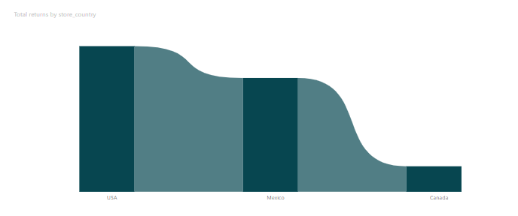

**Total returns by store type**

1. In the first visual it shows Total returns by store country and in that **USA** have the **maximum** returns and **Canada** have the **minimum returns.** It is a **ribbon chart**.
2. In the second visual it is a donut chart showing total returns by store type. the **maximum** **returns** has **deluxe supermarket** and the **minimum returns** has **small grocery** which is **violet in color.**